**Cypher Query Language Sample Questions:**

1. Display the movie’s titles that “Kevin Bacon” acted in.

1. Display the movie’s titles that “James Marshall” directed.

MATCH (m:Movie)<-[:DIRECTED]-(p:Person{name:"James Marshall"}) RETURN m.title as Title

1. How many movies that “Ben Miles” acted in?

1. How many movies that “Clint Eastwood” acted in and directed?

Sample Query:

To get movies with person that both acted and directed in same movie

1. Show the movie’s titles that “Clint Eastwood” acted in and directed.

1. Display the list of persons and roles who acted in movie “The Green Mile”.

NO files found with The Green Mile and Role as properties

~~same as below

1. List the title’s movies and the number of actors?

1. How many movies that “Ron Howard” directed?

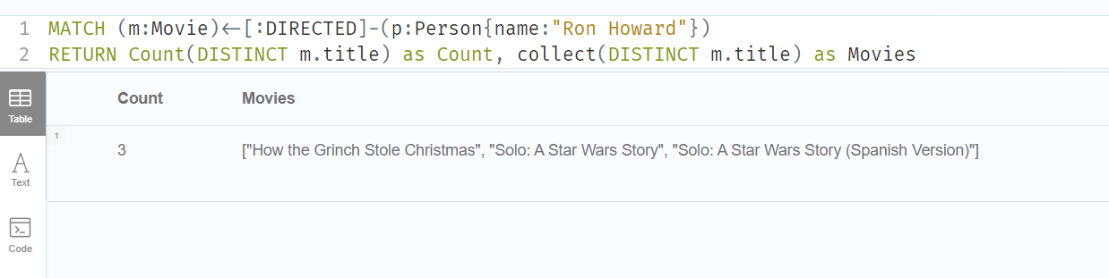

1. Show the movie’s titles that was released in 2009.

1. Who is a person that produced the movie “The Matrix”?

If there is produced relationship, then will be like same above query

MATCH (m:Movie{title:"The Matrix"})<-[:Produced]-(p:Person)

RETURN p.name

If producers are in properties of movie

MATCH (m:Movie{title:"The Matrix", })

RETURN m.producers

1. Who is a person that acted as role “Neo” in movie “The Matrix”?
2. Who are the persons that follow “Jessica Thompson”?
3. How many the persons who follow “Angela Scope”?
4. Display the name of persons, birthyears who born before 1990.
5. List the name of persons and movie’s titles who acted in the same movies that “Al Pacino” acted in.

1. List the name of persons and movie’s titles who directed in the movies that “Demi Moore” acted in.

1. List the movie’s titles and released years that released before 1998.

1. List the roles that “Tom Hanks” acted in the movies “The Polar Express”?
2. List the name of actors who acted more than two roles in the movie.
3. Who are the persons directed and acted in the same movie?

